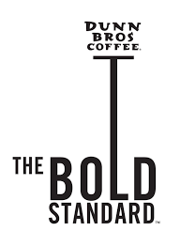

**Fresh Roasted Daily**

**Whole Bean Coffee**

**1 lb. bags**

Product provided by:

Dunn Bros.

Buffalo, MN